PRACTICAL NO.03

**a.Write a MongoDB query to use sum, avg, min and max expression.**

**Sum**

Query :



Output :

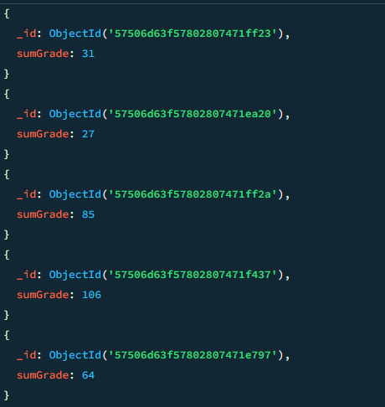

**Avg**

Query :



Output :

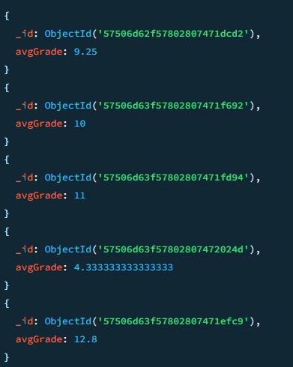

**Min**

Query :



Output :

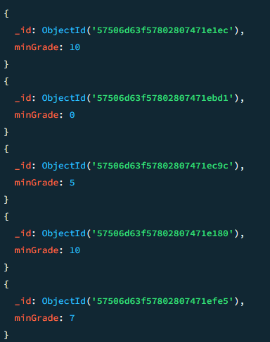

**Max**

Query :

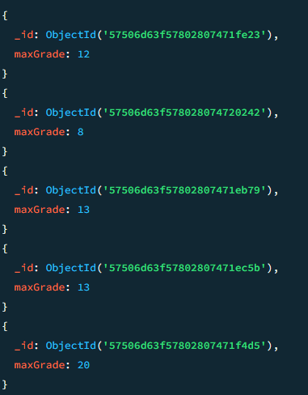

Output :

**b.Write a MongoDB query to use push and addToSet expression.**

**Push**

Query :



Output :

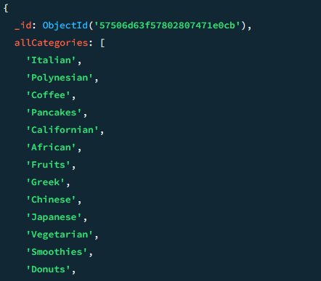

**addToset**

Query :



Output :

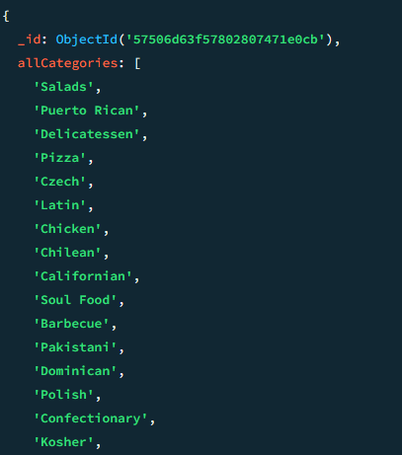

**c.Write a MongoDB query to use first expression.and last**

Query :



Output :

